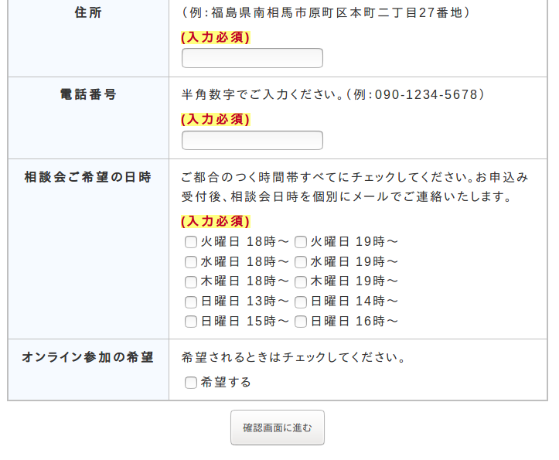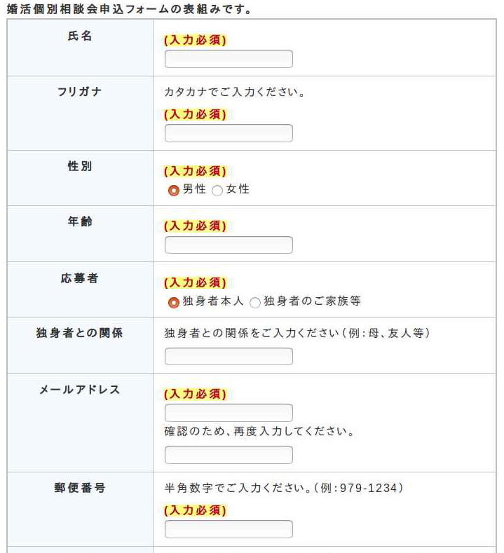

**Check all dates/times that work for you.**

**Desired Dates/Times**

**Sunday from 3pm Sunday from 4pm**

**Sunday from 1pm Sunday from 2pm**

**Thursday from 6pm Thursday from 7pm**

**Tuesday from 6pm Tuesday from 7pm**

**Wednesday from 6pm Wednesday from 7pm**

**Check your information and hit this button to confirm.**

**If you wish to request an online consultation, check this box.**

**Postal Code**

**Please write in twice to confirm.**

**(Mom/Dad/Etc.)**

**Single Person’s Family, Etc.**

**Single Person**

**Type of Applicant**

**Gender**

**Furigana**

**Full Name**

**０７０－４４４４－２２２２**

**Telephone Number**

**(Full Address Here)**

**９７５－０００５**

**２７**

**Age**

**Male Female**

**(Furigana of Name)**

**(Last First Middle)**

**(○○@○○.COM)**

**(○○@○○.COM)**

**If family, how are you related?**

**Online Request**

**Address**

**Email Address**

**Relation to Single Person**

**Digital Application Form (English Instructions)**